SRM Institute of Science and Technology, Kattankulathur
Department of Mathematics
Assignment-I
18MAB201T-Transforms and Boundary Value Problems
Academic Year: 2021-2022
Answer All the Questions (5 * 12=60 Marks)
- (i) Form the pde by eliminating  from 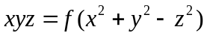
(ii) Form the pde by eliminating from 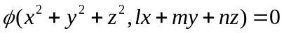
- (i) Solve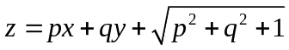
(ii)Solve 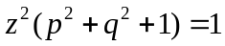
- (i) Solve 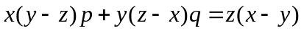
(ii) Solve 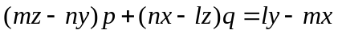
- (i) Solve 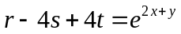
(ii)Solve 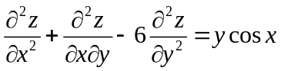
- Solve

